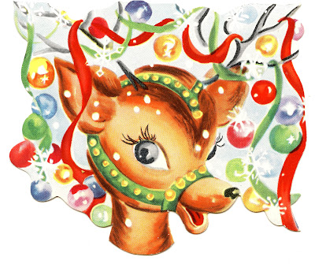

Putty Christmas Party 2021
GET READY TO MINGLE AND JINGLE
You are invited to join in the Christmas fun
on
Saturday 11th DEC @5pm
for a
FESTIVE CHRISTMAS FEAST
Drinks and light refreshments
Fun, games, lollies and activities for the kids
A visit from SANTA @ 6.15*
Followed by a Christmas feast,
Mary Stokes is supplying,all cooked,,
-traditional roast meats ie,beef,pork,lamb,chicken,turkey -gravy, apple sauce
-fresh prawns
-a few side dishes
-Please feel free to bring a plate/dish to contribute
-It would be great if you could let us know what you intend to bring.
Bar open @5pm -NO BYO
COVID safe event.
*Please supply a small gift for your child (with their name clearly identified on the gift).
Santa will distribute the gifts
Presents to be in the kitchen by 6pm ready for loading
into the sled

Event details contact
Kimberley Jane
0488692459 040795335

