THIS COMING SATURDAY - BOOK WITH GUILLAUME
PHONE 0466 572 827
A RACLETTE LUNCH AT PUTTY HALL – Saturday 12thAugust
Make a booking and join our own French Raclette chef at Putty Hall. Lunch will begin at 1.00pm and finish sometime….. later. Cost is $35 per person.

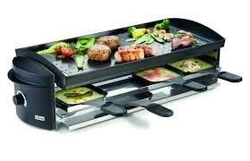

All reactions:
44

